**Sprint 3 Plan**Product Name: Canvas To Calendar

Team Name: Kirb Squad

Sprint Completion Date: 05/23/2023

Revision Number: 0

Revision Date: N/A

**High Level Goals**

* **Goal**

We want to fully integrate all the individual modules we have been working on into one final product, this will be our minimum viable product (MVP). It will essentially be able to scrape user’s assignment due dates through a locally generated access token inputted into our extension. Which will be stored into Chrome’s Storage API and use these dates to create events in the corresponding user’s Google Calendar with its API.

* **List of User Stories**

As a student, I want to be able to interact with the Canvas To Calendar extension, so that I can signal it to get the assignments from my current page. [3.1]

**Task 1**: Include a button in the previous design of the UI that best fits the aesthetic of the overall design.

(~1 hour)

As a student, I need to have the Canvas To Calendar Chrome extension be able to create events of the assignments it has gathered. [3.2]

**Task 1**: Continue implementing the Google Calendar’s API within the source code to make requests for new events.

(~3 hours)

As a student, I want to selectively pick and choose what assignments to put on Google Calendar. [3.3]

**Task 1:** Create a menu for allowing users to choose which classes to get assignments from.

(~2 hours)

**Task 2:** Create an option for users to select assignments they do not want to put on the calendar.

(~2 hours)

As a student, I want to be able to customize my Canvas page to my liking with various options in order to declutter and make my Canvas page more readable. [3.4]

**Task 1:** Create a UI that is consistent with the chrome extension theme to be able to select which tweaks the user wants to apply to their canvas page.

(~3 hours)

**Task 2:** Allow chrome to remember the tweaks applied so you don't need to reapply them each time you open canvas.

(~5 hours)

**Team Roles**

**Myles Marr**: Product Owner, Developer

**Lucas Michellys**: Developer

**Kaled Barraj**: Developer

**Utkarsh Pandey**: Scrum Master, Developer

**Johan Suresh**: Developer

**Initial Setup**

* **Task Assignment**

**Myles Marr**: [3.4], Task 1 & 2

**Lucas Michellys**: [3.1], Task 1

**Kaled Barraj**: [3.2], Task 1

**Utkarsh Pandey**: [3.3], Task 1 & 2

**Johan Suresh**: [3.2], Task 1

* **Burnup Chart**

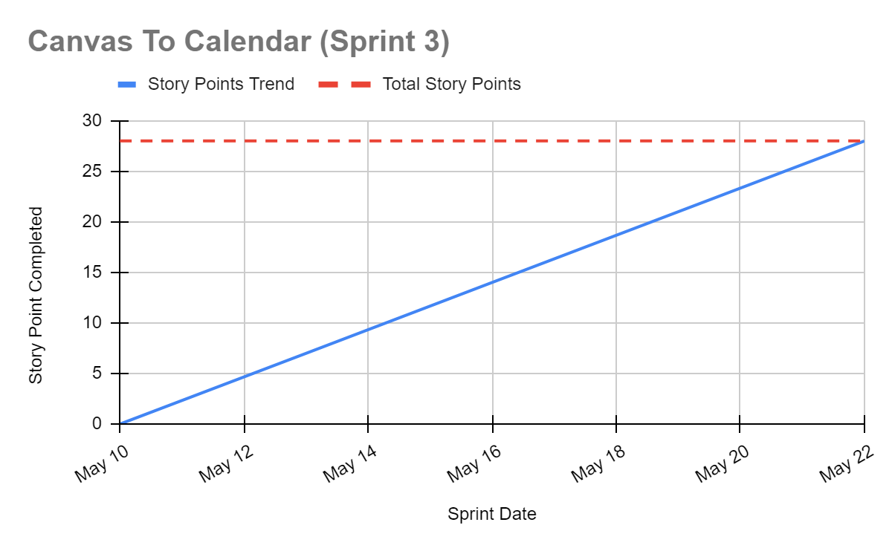

* **Scrum Board**

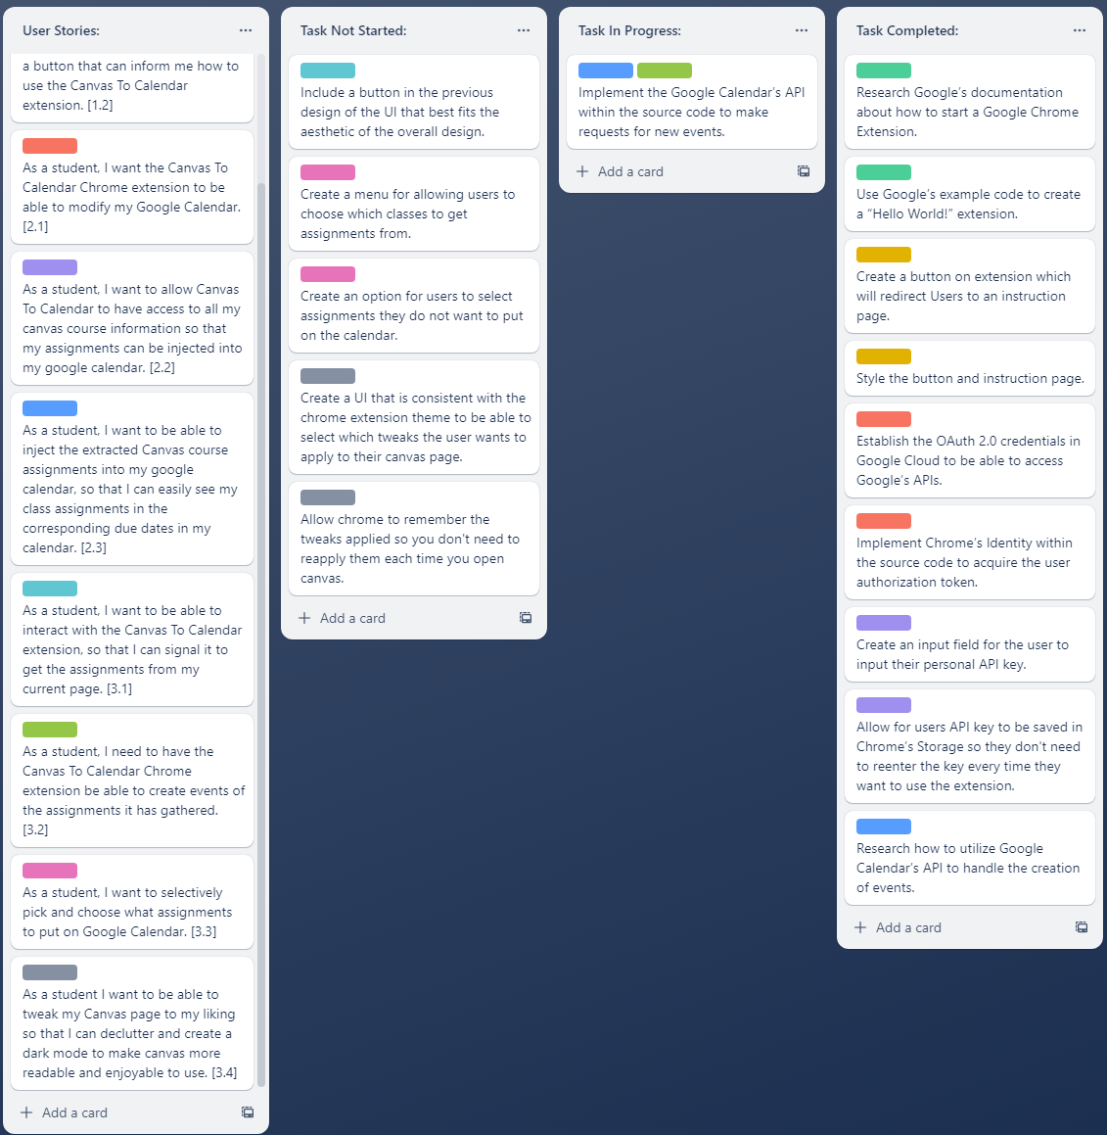

**Scrum Meeting Times**

**Monday:** In the Engineering 1, (9:15 am - 10:15 am)

**Wednesday:** After Zoom with TA, (4:50 pm - 5:20 pm)

**Friday**: Over Discord, (5:00 pm - 5:30 pm)